Estimation and Confidence Intervals

Confidence Intervals for the Mean When $σ$ Is Unknown
When s is known and the sample size is 30 or more, or the population is normally distributed if the sample size is less than 30, the confidence interval for the mean can be found by using the z distribution. However, most of the time, the value of $σ$is not known, so it must be estimated by using s, namely, the standard deviation of the sample. When s is used, especially when the sample size is small, critical values greater than the values for $z_{\frac{α}{2}}$ are used in confidence intervals in order
to keep the interval at a given level, such as the 95%. These values are taken from the Student t distribution ,most often called the t distribution.

Application of Confidence Intervals using t-distribution in Computer Science
1.Algorithm Performance Analysis: You've developed a new sorting algorithm and want to estimate its average execution time. You run it 20 times on a standard dataset and record the execution times.
Application: You can construct a 95% confidence interval for the true mean execution time. This interval would tell you, with 95% confidence, that the true average execution time of your algorithm lies within that range.
2.Memory Usage of Applications: You are analyzing a new software application and want to determine its average memory footprint. You run the application 15 times and record its peak memory usage.
Application: A 99% confidence interval for the mean memory usage can give you a strong estimate of the typical memory requirements, crucial for system resource planning.
3.Software Testing and Bug Detection: You have a new testing tool, and you want to estimate the average number of bugs it can detect per hour of testing. You run the tool for 25 one-hour sessions.
Application: A confidence interval for the average bug detection rate can help quantify the tool's effectiveness and compare it to existing tools.

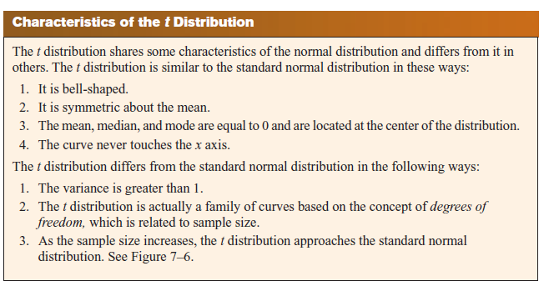

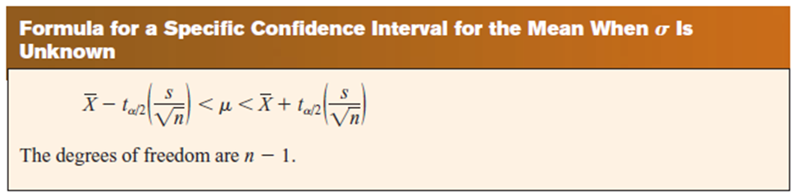

How to find t value from the table
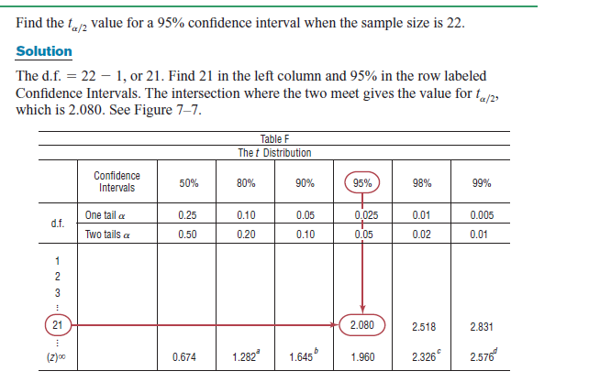

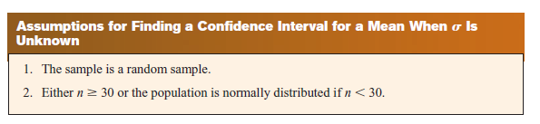
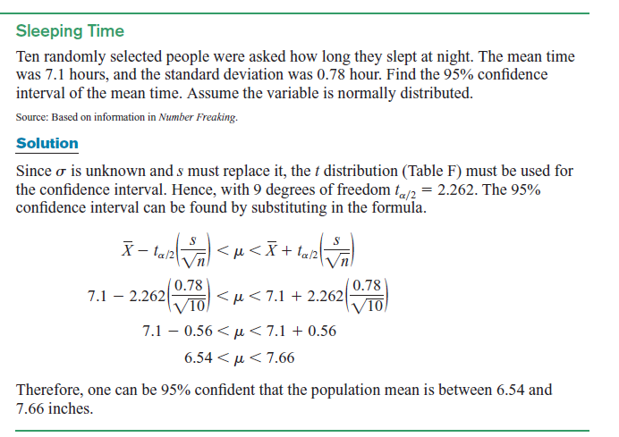

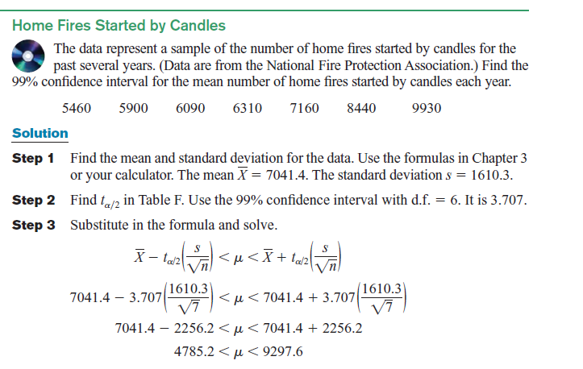
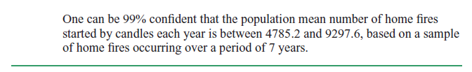
Practice Question
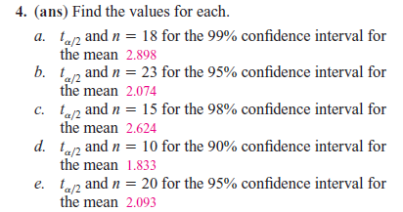
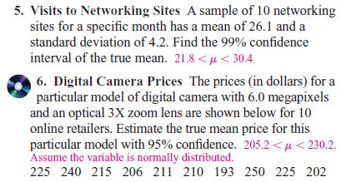
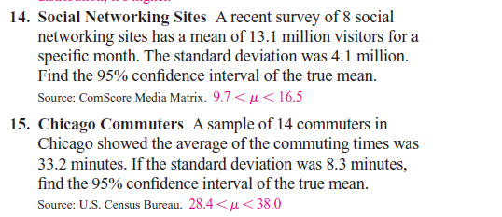

Confidence Intervals and Sample Size for Proportions
At USA today’s Snapshots feature stated that 12% of the pleasure boats in the United States were named Serenity. The parameter 12% is called a proportion. It means that of all the pleasure boats in the United States, 12 out of every 100 are named Serenity. A proportion represents a part of a whole. It can be expressed as a fraction, decimal, or percentage.

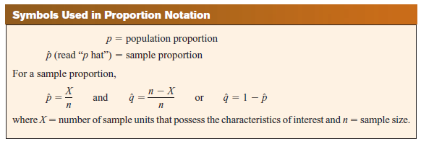
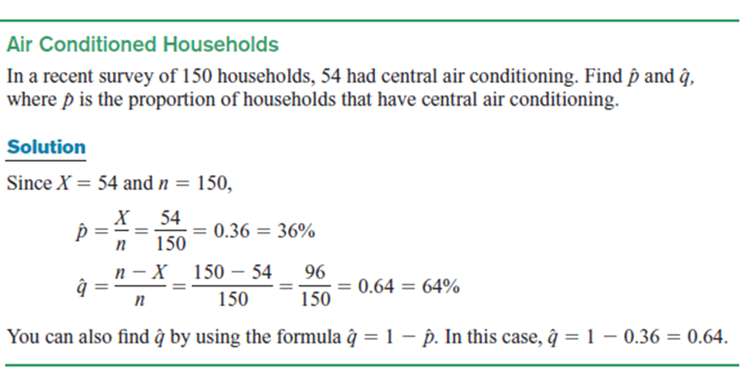
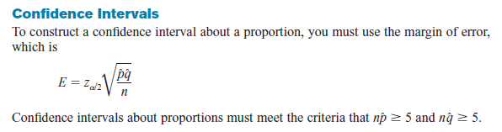
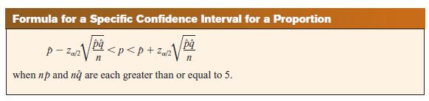

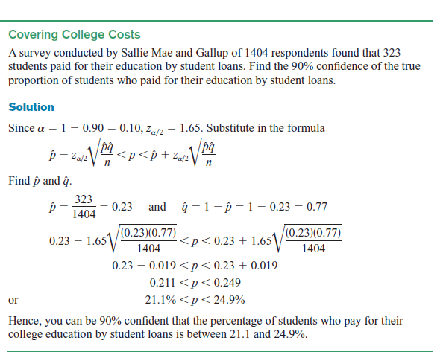

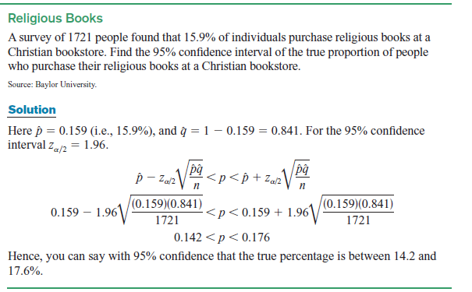

Practice Question
